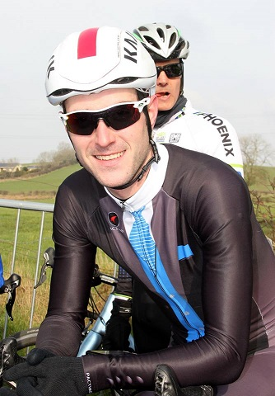

Ronan Mc Laughlin

ACTIVE TRAVEL OFFICER







For further information about the work of Sustrans in schools please visit: www.sustrans.org.uk/schools

Hi - I’m Ronan - your Sustrans Active Travel Officer.

I’m very happy to be supporting the pupils and staff in your school and together we can increase the number of children walking, cycling and scooting to school and more of their everyday journeys.

Throughout the year we will organise lots of great activities to encourage a fun and healthy active travel culture within the school.

Working in partnership with your school community we can improve health, encourage independence, reduce congestion and air pollution, increase pupil alertness and make the school journey a more enjoyable experience for pupils and their families.